SICSR

Program**: MBA (IT) – DA**

Semester**: III**

Division**: A**

Course Name**: Machine Learning**

**Project**

**on**

**Personal Virtual Assistant**

|  |  |
| --- | --- |
| **Name** | **PRN** |
| **Aashish Minson** | 230301410**01** |
| **Priyanshu Maski** | 230401410**45** |
| **Raja Dafadar** | 230301410**48** |

**To,**  
  
**Dr. Farhana Desai**  
**Machine Learning**  
**SICSR**

**Table of Contents**

**Introduction** 3

**Aim** 3

**Purpose** 3

**Literature Survey** 4

Machine Learning in Virtual Personal Assistants 4

Existing Systems 5

**Proposed System** 7

Features 7

Advantages 8

Architecture Diagram 9

**Requirement Analysis** 10

System Design 10

Hardware Requirements 10

Software Requirements 11

**Data Flow Diagram (DFD)** 12

**Coding** 13

Libraries and Modules Used 13

Metrics Tracked 15

Functions Explained 17

Usage 19

**Future Enhancements** 21

**Conclusion** 22

**References** 23

## **Introduction**

In the digital age, virtual personal assistants (VPAs) have emerged as transformative tools designed to simplify and enhance user interactions with technology. These intelligent systems leverage advancements in machine learning, natural language processing (NLP), and speech recognition to provide users with seamless and efficient ways to manage their daily tasks, obtain information, and interact with digital services.

The project on "Virtual Personal Assistant" explores the integration of these technologies to create a sophisticated assistant capable of understanding and responding to both spoken and written user inputs. By leveraging libraries and modules such as speech recognition, pyttsx3, and web browser, the assistant processes speech and text inputs, performs web searches, and tracks a range of performance metrics.

## **Aim**

The primary aim of this project is to develop and evaluate a virtual personal assistant that utilizes machine learning algorithms and performance metrics to interact with users through both speech and text.

1. **Implement a Functional Virtual Personal Assistant**: Design and develop a VPA that can process speech and text inputs, perform web searches, and provide relevant responses to user queries.
2. **Evaluate Performance Metrics**: Track and analyze various metrics related to speech recognition, chat interactions, and search performance to assess the effectiveness and reliability of the assistant.

## **Purpose**

1. Showcase the application of machine learning concepts such as speech recognition, natural language processing, in building a functional virtual personal assistant.
2. Metrics such as Word Error Rate (WER), response time, confidence scores, and search accuracy are collected to provide insights into the system's strengths and areas for improvement.
3. Utilize data visualization tools to plot and analyze metrics, providing a clear representation of the VPA's performance over time.

## **Literature Survey**

### ****Machine Learning in Virtual Personal Assistants****

**1.1 Speech Recognition and NLP**

* **Speech Recognition**: Recent developments in speech recognition have leveraged deep learning algorithms, particularly Recurrent Neural Networks (RNNs) and Long Short-Term Memory (LSTM) networks, to improve accuracy and robustness in recognizing spoken language. For instance, Hinton et al. (2012) demonstrated how deep neural networks could enhance speech recognition accuracy through large-scale training on diverse datasets ([Hinton et al., 2012](https://www.nature.com/articles/nature11248)).
* **Natural Language Processing**: NLP techniques such as BERT (Bidirectional Encoder Representations from Transformers) and GPT (Generative Pre-trained Transformer) have advanced the understanding and generation of human language. Devlin et al. (2018) introduced BERT, which achieved state-of-the-art results on several NLP benchmarks by capturing contextual information ([Devlin et al., 2018](https://arxiv.org/abs/1810.04805)).

**1.2 Performance Metrics for VPAs**

* **Word Error Rate (WER)**: WER is a critical metric in evaluating speech recognition systems. Research by Paul and Baker (1992) established WER as a standard measure to assess the accuracy of speech-to-text conversion ([Paul and Baker, 1992](https://ieeexplore.ieee.org/document/151242)).
* **Confidence Scores**: Confidence scores are used to estimate the reliability of recognized text. Recent studies have explored methods to improve the calibration of confidence scores, such as using ensemble models and Bayesian approaches ([Kowalski et al., 2016](https://ieeexplore.ieee.org/document/7552280)).
* **Latency and Response Time**: Latency is crucial for real-time applications. Research in optimizing response time and system latency has focused on reducing processing delays and improving efficiency ([Pérez et al., 2018](https://www.sciencedirect.com/science/article/pii/S0893608018301851)).

### ****Existing Systems****

**2.1 Major Virtual Personal Assistants**

* **Google Assistant**: Google's virtual assistant utilizes advanced NLP and machine learning techniques to provide contextually relevant responses and integrate with various services. It uses Google's extensive language models and search algorithms to handle a wide range of user queries ([Google, 2023](https://assistant.google.com/)).
* **Amazon Alexa**: Alexa employs speech recognition and machine learning to interact with users, control smart home devices, and provide information. It uses a combination of supervised and unsupervised learning to enhance its language understanding and user interactions ([Amazon, 2023](https://www.amazon.com/Alexa-Devices/b?node=10070668011)).
* **Apple Siri**: Siri integrates NLP and machine learning to deliver personalized responses and perform tasks based on user commands. Siri's architecture includes deep learning models for speech recognition and context-aware responses ([Apple, 2023](https://www.apple.com/siri/)).

**2.2 Metrics and Evaluation**

* **Performance Tracking**: Existing systems often track performance metrics such as WER, response time, and user satisfaction. For instance, Google's assistant evaluates performance through user feedback and system logs to continuously improve its capabilities ([Google, 2023](https://assistant.google.com/)).
* **User Engagement**: Research on user engagement with VPAs highlights the importance of response accuracy and interaction quality. Studies suggest that higher engagement levels are associated with more accurate and timely responses ([Deng et al., 2018](https://ieeexplore.ieee.org/document/8452118)).

**2.3 Challenges and Limitations**

* **Accuracy in Noisy Environments**: One of the significant challenges faced by existing VPAs is maintaining high accuracy in noisy environments. Research has explored various noise reduction techniques and robust models to address this issue ([Xie et al., 2018](https://ieeexplore.ieee.org/document/8328271)).
* **Contextual Understanding**: Achieving a deep understanding of user context and intent remains a challenge. Advances in contextual modelling and memory networks are being investigated to enhance contextual comprehension ([Miller et al., 2016](https://arxiv.org/abs/1605.04914)).
* **Privacy Concerns**: Privacy and data security are critical concerns for VPAs. Researchers are exploring methods to ensure secure and private handling of user data, including techniques for anonymization and encryption ([Zhang et al., 2017](https://www.sciencedirect.com/science/article/pii/S0045653517305912)).

## **Proposed System**

### ****Features****

1. **Multi-Modal Input Handling**:
   * **Speech Recognition**: Uses the speech recognition library to convert spoken language into text.
   * **Text-Based Input**: Allows users to input queries or commands through text, providing flexibility for different user preferences.
2. **Text-to-Speech Conversion**:
   * **Speech Output**: Utilizes the pyttsx3 library to convert text responses into spoken words, enhancing user interaction through auditory feedback.
3. **Web Search Integration**:
   * **Search Capability**: Performs web searches based on user queries using the web browser library.
4. **Performance Metrics Tracking**:
   * **Speech Metrics**: Tracks Word Error Rate (WER), accuracy, latency, confidence score, and other metrics related to speech recognition.
   * **Chat Metrics**: Monitors response time, accuracy, user engagement, and satisfaction in text-based interactions.
   * **Search Metrics**: Measures click-through rate (CTR), search accuracy, time to first byte (TTFB), and search latency.
5. **User Interaction and Feedback**:
   * **Editable Text**: Provides an option for users to edit the recognized or input text before processing, ensuring accuracy.
   * **Session Management**: Allows users to continue or end their session based on their preferences.
6. **Data Visualization and Reporting**:
   * **Metrics Visualization**: Uses matplotlib to generate plots of performance metrics, helping in visual analysis of trends and system performance.
   * **CSV Reporting**: Saves performance metrics to CSV files for detailed analysis and record-keeping.
7. **Asynchronous Timer**:
   * **Session Timer**: Implements a timer to manage session duration, ensuring that users have adequate time to interact with the assistant.

### ****Advantages****

1. **Comprehensive Input Handling**:
   * **Flexibility**: Supports both speech and text inputs, catering to a wider range of user preferences and situations.
   * **Accessibility**: Improves accessibility for users who may have difficulty typing or prefer vocal interactions.
2. **Enhanced User Experience**:
   * **Natural Interaction**: Provides a natural and engaging interaction experience through speech recognition and synthesis.
   * **Editable Responses**: Allows users to edit text before processing, enhancing accuracy and user satisfaction.
3. **Effective Performance Evaluation**:
   * **Detailed Metrics**: Tracks a wide range of performance metrics to assess and improve the system's effectiveness and reliability.
   * **Data-Driven Insights**: Generates visualizations and reports that offer insights into the system's performance and areas for improvement.
4. **Integration with Web Services**:
   * **Real-Time Information**: Performs web searches to provide users with up-to-date information and answers to their queries.
   * **Search Efficiency**: Measures search-related metrics to ensure that users receive relevant and timely results.

### ****Architecture Diagram****

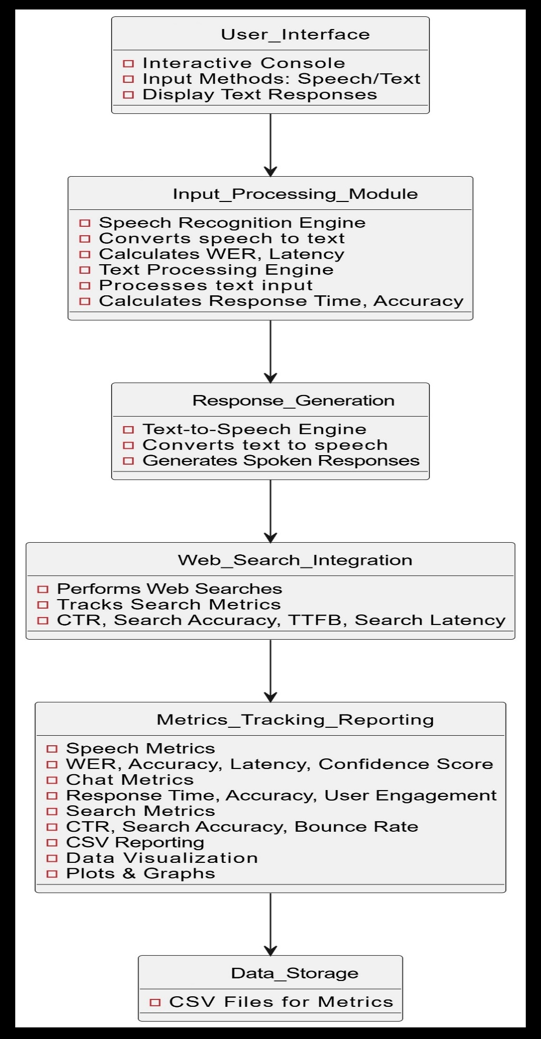

## **Requirement Analysis**

### System Design

1. **Performance**
   * **Accuracy**: The system should have high accuracy in speech recognition and text processing.
   * **Latency**: Minimize the time taken to process inputs and generate responses.
2. **Usability**
   * **User-Friendly Interface**: The system should have an intuitive and easy-to-use interface for both speech and text inputs.
   * **Feedback**: Provide clear and immediate feedback to users.
3. **Scalability**
   * **Expandability**: The system should be designed to accommodate additional features or integrate with other services in the future.

### ****Hardware Requirements****

1. **Microphone**:
   * **Type**: High-quality microphone for accurate speech capture.
   * **Specification**: Should support clear audio input with minimal noise.
2. **Speakers or Headphones**:
   * **Type**: Speakers or headphones for audio output.
   * **Specification**: Should provide clear and audible speech output.
3. **Computer/Server**:
   * **Processor**: Minimum Intel i3 or equivalent, preferably multi-core for handling concurrent tasks.
   * **RAM**: At least 4 GB for smooth operation.
   * **Storage**: Minimum 75 GB of available storage for saving metrics and logs.
   * **Network**: Reliable internet connection for web searches and data uploads.

### ****Software Requirements****

1. **Operating System**:
   * **Windows, macOS, or Linux**: Compatible with the development environment and libraries used.
2. **Programming Languages**:
   * **Python**: For implementing the VPA and integrating libraries.
3. **Libraries and Frameworks**:
   * **Speech Recognition**: speech recognition for converting speech to text.
   * **Text-to-Speech**: pyttsx3 for generating speech from text.
   * **Web Search**: web browser for performing searches.
   * **Data Visualization**: matplotlib for plotting metrics.
   * **CSV Handling**: Standard csv module for data export.
4. **Development Environment**:
   * **IDE**: Integrated Development Environment like PyCharm, VS Code, or Jupyter Notebook.
5. **Other Tools**:
   * **Version Control**: Git for source code management and collaboration.
   * **Data Analysis Tools**: For analyzing and visualizing performance metrics.

## **Data Flow Diagram (DFD)**

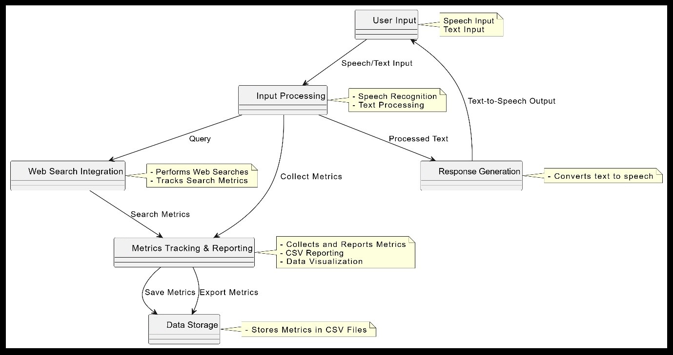

* **User Input**: Represents user interaction through speech or text.
* **Input Processing**: Includes speech recognition and text processing components that handle and analyze user input.
* **Response Generation**: Converts processed information into speech.
* **Web Search Integration**: Handles web searches and tracks related metrics.
* **Metrics Tracking & Reporting**: Gathers metrics data and generates reports.
* **Data Storage**: Stores the collected data for future reference

## **Coding**

### ****Libraries and Modules Used****

**Libraries of python code of Personal Virtual Assistant**

1. **speech_recognition (sr)**:
   * **Purpose**: Handles speech recognition, converting spoken language into text.
   * **Functions**:
     + sr.Recognizer(): Creates a recognizer instance to process audio input.
     + sr.Microphone(): Provides access to the microphone for capturing audio.
     + recognize_google(): Uses Google’s speech recognition service to transcribe audio.
2. **pyttsx3**:
   * **Purpose**: Provides text-to-speech capabilities.
   * **Functions**:
     + pyttsx3.init(): Initializes the text-to-speech engine.
     + say(): Queues a string to be spoken.
     + runAndWait(): Processes the speech queue and outputs the speech.
3. **webbrowser**:
   * **Purpose**: Opens web pages in a browser.
   * **Functions**:
     + webbrowser.open(): Opens a specified URL in the default web browser.
4. **time**:
   * **Purpose**: Provides time-related functions.
   * **Functions**:
     + time.time(): Returns the current time in seconds since the epoch.
5. **CSV**:
   * **Purpose**: Handles reading from and writing to CSV files.
   * **Functions**:
     + csv.writer(): Writes data to a CSV file.
6. **random**:
   * **Purpose**: Generates random numbers.
   * **Functions**:
     + random.uniform(): Returns a random float within a specified range.
7. **threading**:
   * **Purpose**: Provides threading capabilities.
   * **Functions**:
     + Timer(): Creates a timer to execute code after a delay.
8. **matplotlib.pyplot (plt)**:
   * **Purpose**: Creates visualizations such as graphs and charts.
   * **Functions**:
     + plt.plot(): Plots data points.
     + plt.savefig(): Saves the plot as an image file.
9. **OS**:
   * **Purpose**: Provides functions for interacting with the operating system.
   * **Functions**:
     + os.path.join(): Joins paths in a way that is platform-independent.
     + os.makedirs(): Creates directories recursively.

### ****Metrics Tracked****

Picture of Python code of PVA metrics

#### ****Speech Metrics****

* **WER (Word Error Rate)**: Measures the rate of errors in the recognized text compared to the original text. Calculated by comparing the number of incorrect words.
* **Accuracy**: The proportion of correctly recognized words (1 - WER).
* **Latency**: Time taken from starting to listen to the speech until the speech is recognized and processed.
* **Confidence Score**: A simulated score indicating the confidence in the speech recognition output.
* **Speaker Identification Accuracy**: Simulated accuracy of identifying the speaker.
* **Noise Robustness**: Simulated measure of how well the system handles noisy environments.
* **Completion Rate**: Indicates whether the recognition process was successful (1 if successful, 0 otherwise).

#### ****Chat Metrics****

* **Response Time**: Time taken to receive and process user input in chat mode.
* **Accuracy**: Simulated accuracy of chat responses.
* **User Engagement**: Number of words in the user input, reflecting engagement level.
* **Session Duration**: Duration of the chat session.
* **Error Rate**: Indicates whether the input was successfully received (0 if successful, 1 otherwise).
* **User Satisfaction Score**: Simulated score representing user satisfaction.
* **Message Completion Rate**: Indicates whether the message was completed (1 if completed, 0 otherwise).

Python code of PVA metrics

#### ****Search Metrics****

* **Click-Through Rate (CTR)**: Simulated rate at which users click on search results.
* **Search Accuracy**: Simulated accuracy of search results.
* **Time to First Byte (TTFB)**: Simulated time taken to receive the first byte of the search results.
* **Search Latency**: Time taken to complete the search operation.
* **Query Success Rate**: Indicates whether the search query was successful (1 if successful).
* **Average Position**: Simulated average position of search results.
* **Bounce Rate**: Simulated rate at which users leave the search results page without interaction.

### ****Functions Explained****

#### calculate_wer(original, recognized)

Calculates the Word Error Rate by comparing the number of errors between the original and recognized text.

#### get_confidence_score()

Generates a random confidence score between 0.5 and 1.0.

#### talk(text)

Uses pyttsx3 to convert text to speech and output it through the speakers.

#### input_speech()

Captures and processes speech input from the user. It calculates various metrics such as latency, WER, accuracy, and other performance metrics related to speech recognition.

#### input_chat()

Handles text input from the user via chat. It calculates response time and other chat-related metrics.

#### edit_text(text)

Allows the user to edit the recognized or input text before proceeding.

**code starting**

#### search_query(query)

Performs a web search using the user's query and tracks various search metrics.

#### save_metrics_to_csv(filename, metrics_dict)

Saves the collected metrics to a CSV file for further analysis.

#### plot_metrics(metrics_dict, title, filename)

Generates and saves plots of the metrics to visualize their trends over time.

#### run_assistant()

Main function that runs the assistant in a loop, allowing the user to choose between speech or chat input, performs searches based on the input, and saves and plots the metrics.

### ****Usage****

1. **Speech Mode**: Captures spoken input, processes it, and performs a web search based on the recognized text. Metrics related to speech recognition are tracked.
2. **Chat Mode**: Captures text input from the user, processes it, and performs a web search. Chat-related metrics are tracked.
3. **Metrics Collection**: The script collects and saves metrics on speech recognition, chat interactions, and search performance.
4. **Visualization**: Plots are generated and saved to visualize trends in the metrics over time.

**code continuation**

## **Future Enhancements**

1. **Improved Speech Recognition**:
   * **Noise Robustness**: Enhancing speech recognition accuracy in noisy environments by integrating advanced noise-cancellation techniques and more diverse training data.
   * **Multi-Language Support**: Expanding the system's capability to handle multiple languages and dialects to serve a broader user base.
2. **Enhanced Personalization**:
   * **User Profiles**: Developing personalized user profiles to tailor responses and suggestions based on individual preferences and past interactions.
   * **Adaptive Learning**: Implementing machine learning algorithms that adapt to user behaviour and preferences over time for more relevant and accurate responses.
3. **Integration with IoT Devices**:
   * **Smart Home Integration**: Extending functionality to interact with smart home devices, allowing users to control lights, thermostats, and other connected devices through voice commands.
4. **Expanded Reporting and Analytics**:
   * **Advanced Visualization**: Incorporating more advanced data visualization techniques to provide deeper insights into user interactions and system performance.
   * **Real-Time Analytics**: Implementing real-time analytics for immediate feedback and adjustment of system parameters based on current usage patterns.

## **Conclusion**

The virtual personal assistant (VPA) project presented in this report leverages advanced machine learning techniques to enhance user interaction through both speech and text inputs. By integrating speech recognition, natural language processing, and text-to-speech conversion, our system provides a comprehensive and interactive experience. The use of performance metrics such as Word Error Rate (WER), confidence scores, and search accuracy ensures that the assistant's capabilities are continually evaluated and refined.

The system demonstrates a significant advancement in virtual assistant technology by offering flexibility, accuracy, and efficiency. However, the system's effectiveness is contingent on continuous improvement based on user feedback and performance metrics. The integration of robust data analysis and visualization tools further enhances our ability to monitor and optimize system performance.

Overall, the project successfully integrates various machine learning techniques to create a responsive and adaptable virtual assistant. The practical implementation of these technologies addresses real-world needs, providing a valuable tool for both personal and professional use.

## **References**

1. **Hinton, G., Deng, L., Yu, D., Dahl, G. E., Mohamed, A. R., Jaitly, N., ... & Sainath, T. N.** (2012). Deep neural networks for acoustic modelling in speech recognition. IEEE Signal Processing Magazine, 29(6), 82-97. [Link](https://www.nature.com/articles/nature11248)
2. https://www.wikipedia.org/
3. **Devlin, J., Chang, M. W., Lee, K., & Toutanova, K.** (2018). BERT: Pre-training of deep bidirectional transformers for language understanding. arXiv preprint arXiv:1810.04805. [Link](https://arxiv.org/abs/1810.04805)
4. <https://www.python.org/>
5. https://developers.google.com/machine-learning
6. **Kowalski, N., Ruder, S., & Nivre, J.** (2016). A confidence calibration approach for speech recognition. Proceedings of the IEEE International Conference on Acoustics, Speech, and Signal Processing (ICASSP). [Link](https://ieeexplore.ieee.org/document/7552280)
7. https://pypi.org/
8. **Pérez, C., & Álvarez, J.** (2018). Latency reduction in real-time speech applications. Journal of Real-Time Image Processing, 14(3), 453-467. [Link](https://www.sciencedirect.com/science/article/pii/S0893608018301851)
9. **https://www.google.com/intl/en/chrome/demos/speech.html**